CCC Multi-Factor Authentication

Overview
In order to secure our accounts and data in Microsoft Office 365, the College will enable multi-factor authentication for your account. This will affect:
- Email / Outlook
- OneDrive for Business
- Microsoft Teams
- Anything you use your Office 365 account for

Enrollment Period
During the enrollment period, you will see a message similar to this, prompting you to enroll.
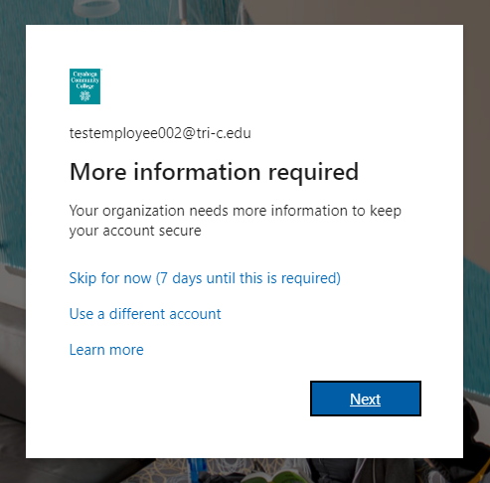
Click Next to enroll now or click Skip to delay enrollment.

Enrollment Process
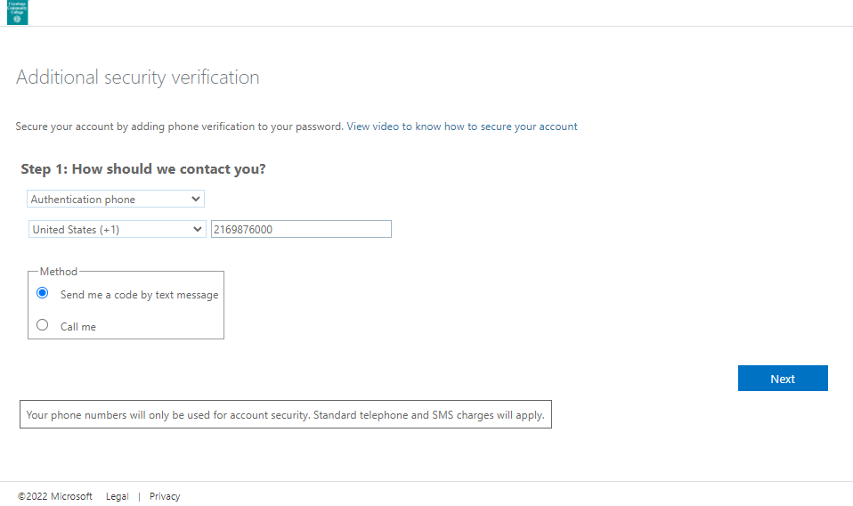

Select a method to enroll. This will be your default method until you change it. You can later add additional methods.
Authentication phone: Cell phone – can receive voice and SMS
Office Phone: Office landline – can only receive voice, no SMS
Mobile App: Microsoft Authenticator Mobile App – login notifications and time-based rotating codes.

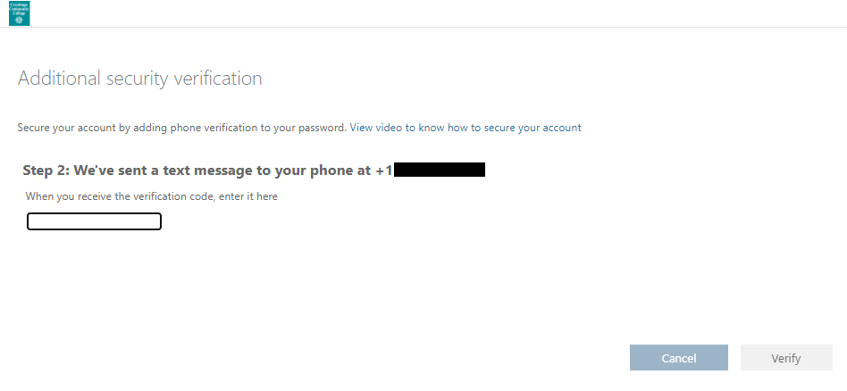
Type in the code, click verify. If you typed it correctly, it will let you know. Then click Done.

Adding Additional MFA Methods
We recommend adding all options available to you:
- Cell phone (for voice and SMS text message codes)
- Home phone, if you have a separate home phone (for voice)
- Office phone (for voice)
- Microsoft Authenticator App install on your cell phone (for offline codes and “push notification”)
- Microsoft Authenticator App install on a tablet, such as an iPad (for offline codes and “push notification”)

- Go to https://365.tri-c.edu/ and log in
- Click the circle in the top right corner and which either has your picture or initials

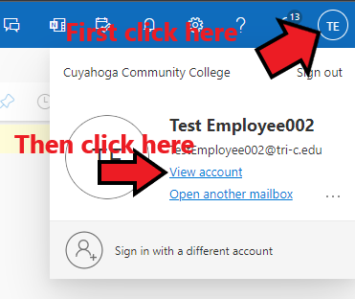
- Then select View account.
- Under Security info, click Update Info.
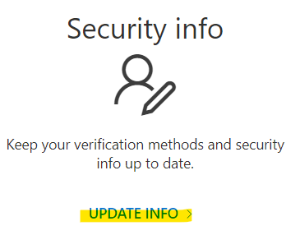
- If you had MFA setup, you might be required to pass an MFA check before proceeding. This is one example of why it is important to have multiple methods enrolled. Then you can change, delete, or add sign-in methods. You can also change your default sign-in method.
- Click Add sign-in method
- It will walk you through adding additional methods. Add as many as possible.

