To view delegates and their permissions:
Open Outlook, click File tab | Info | Account Settings then Delegate Access:
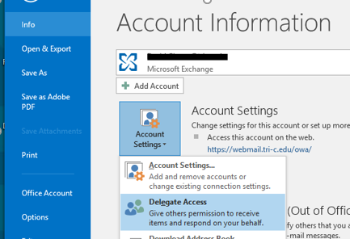
Highlight users name and click on permissions. A separate window will open showing permissions:
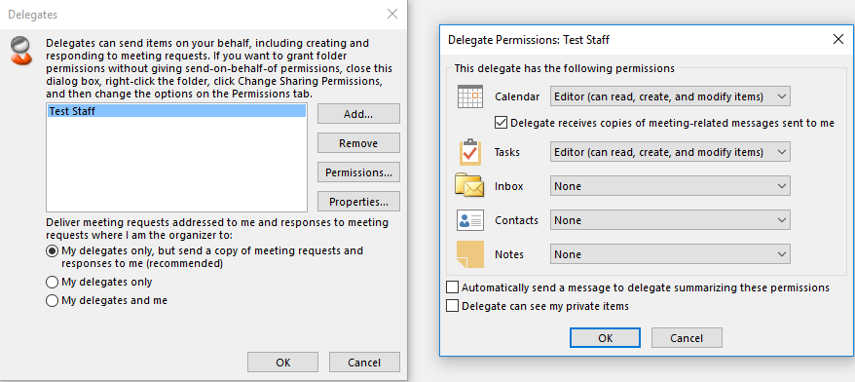
Use this area to record users, folders and permissions to recreate after the move.
Please save to H:!
Delegate / User | Folder | Permissions | Meeting request

