Microsoft Office
2013

QUICK REFERENCE GUIDE FOR TRI-C EMPLOYEES

TABLE OF CONTENTS

Sec. | Chapter | Pg.
 | Adding Shortcuts to the Desktop | 2
 | Removing Shortcuts from the Desktop | 5
 | Pinning Programs to Taskbar | 6
 | Unpinning Programs from Taskbar | 7
 | Edit PDF Document Created in Microsoft Word | 8
 | Open Microsoft Word Documents in a Different View | 13
 | Automatically Open Word Documents in Print Layout Mode | 13
 | Manually Switch Documents to Print Layout Mode | 15
 | Accessing Public Folders in Outlook | 16
 | Microsoft Office Resources # 1 | 19
 | Microsoft Office Resources # 2 | 21
 | Microsoft Office Resources # 3 | 23
 | Advanced Microsoft Office Resources | 25

ADDING SHORTCUTS TO THE DESKTOP:

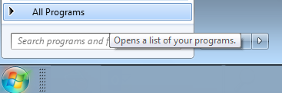
- Click on the Windows Start (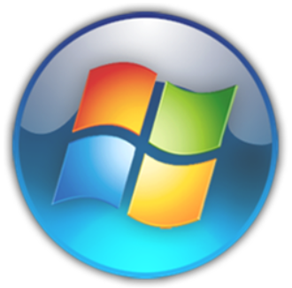) icon from the taskbar. Then select All Programs.

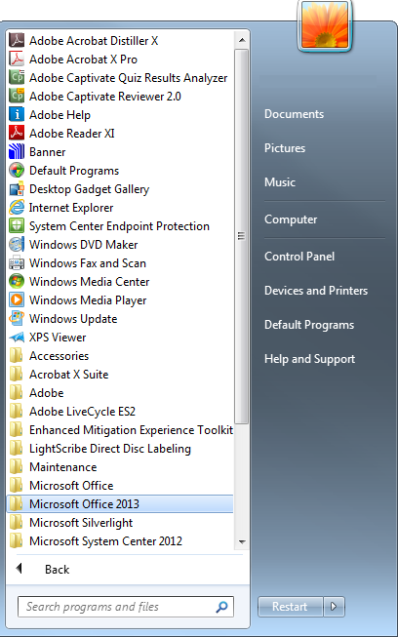

- Scroll down to Microsoft Office 2013 folder. Click once to open the folder.

- Select an Office 2013 program to send to the Desktop.

- Select Send to and then select Desktop (create shortcut).

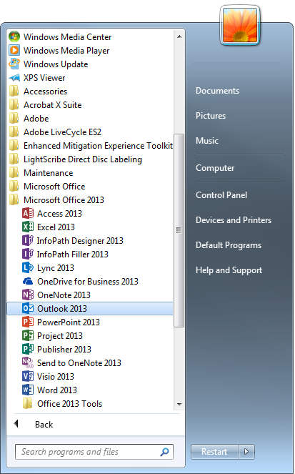
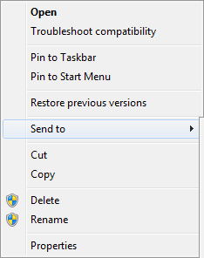
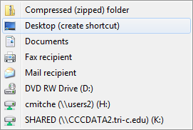

- The program, file, or folder will be sent on your Desktop.

- Click on the program, file, or folder to open.

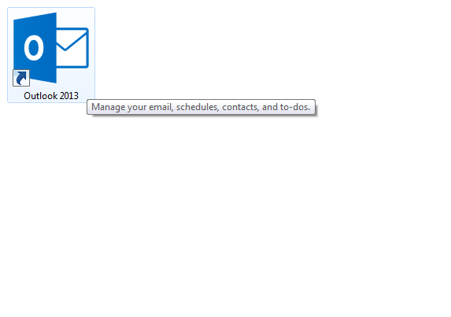

- Repeat this process for every program, file, or folder you would sent to the Desktop.

REMOVING SHORTCUTS FROM THE DESKTOP:

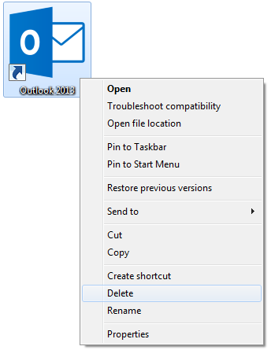
  - Right-click on the program, file, or folder to be deleted from the Desktop. Then select Delete.

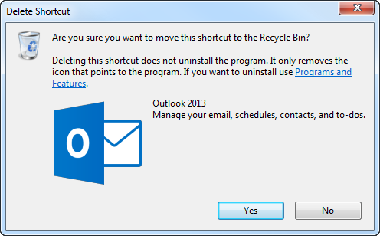
  - Click the () button to move the shortcut to the Recycle Bin.

NOTE:
Programs, files, or folders may be restored back to its original location from the Recycle Bin.

PINNING PROGRAMS TO TASKBAR

Programs can be pinned to the Windows Taskbar for handy access to the application.

- Find the program from the Windows Start menu.

- Right-click on the program and select Pin to Taskbar.

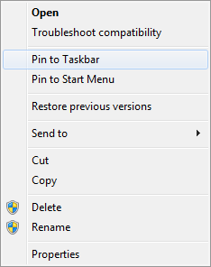

- When the program is closed, the program’s icon will remain on the Windows Taskbar for quicker accessibility. Click on the program’s icon from the taskbar to open.

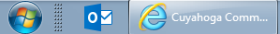

UNPINNING PROGRAMS FROM TASKBAR:

- Right click on the program from the Windows Taskbar then select Unpin this program from taskbar.

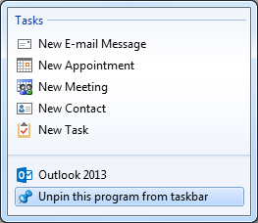

- The program will be removed from the Windows Taskbar.

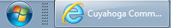
EDIT PDF DOCUMENT CREATED IN MICROSOFT WORD:

A new feature of Word 2013 allows users to open a PDF document, similar to opening a .docx file, where changes can be made, and then saved back to PDF format.

- Open a blank Word document and then click the File tab.

- Click Open on the task pane to navigate to the PDF document you want to edit. Click the () button once the document is located.

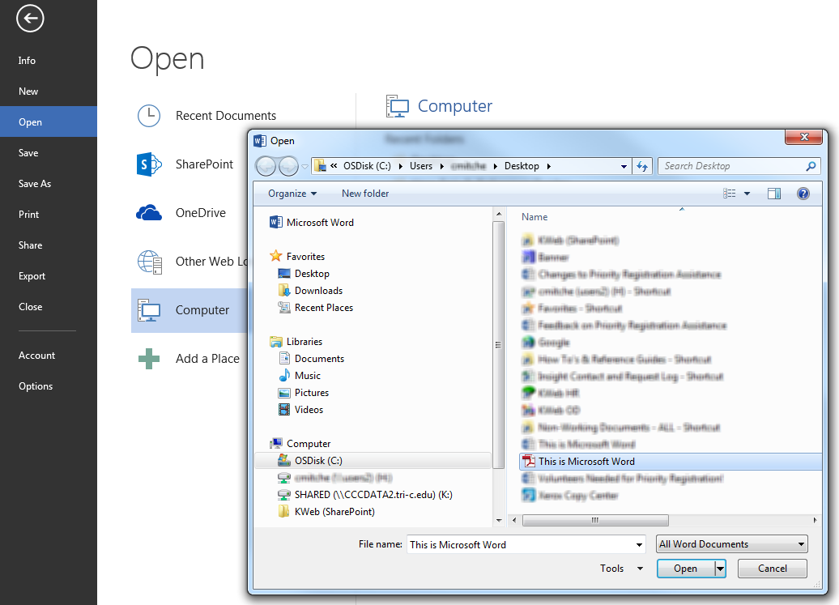

- A dialogue box will appear indicating the PDF document will be converted to an editable Word document.

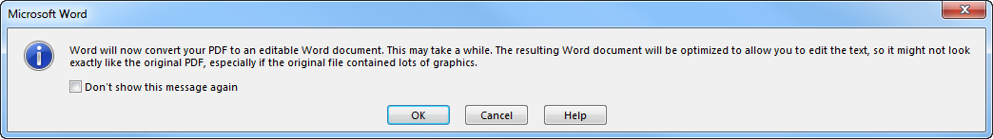
“Word will now convert your PDF to an editable Word document. This may take a while. The resulting Word document will be optimized to allow you to edit the text, so it might not look exactly like the original PDF, especially if the original file contained lots of graphics.”

- Click the () button to allow the conversion.

- The document will open in Word, where you can make your changes. NOTE: You may not be able to edit form fields.

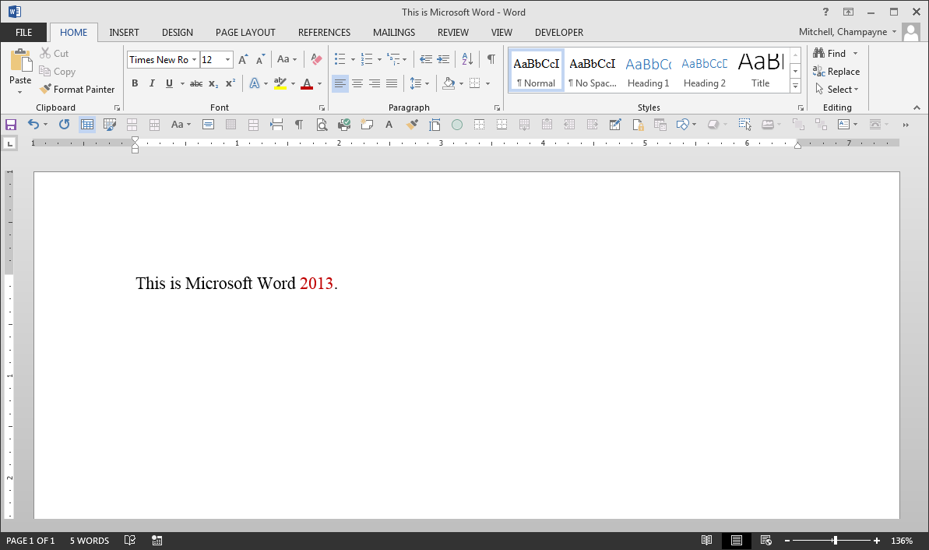
- After making your changes, click the File tab.

- Click Save As on the task pane to navigate to the location where the document will be saved on your computer.

- Click the dropdown arrow next to the ‘Save as type’ field to select PDF from the list.

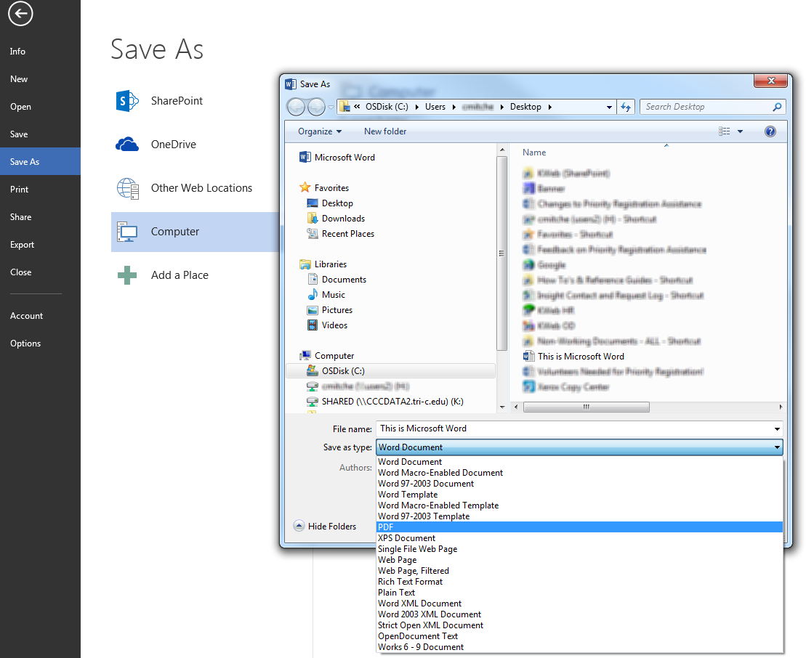
- Click the () button to save the document as a PDF file.

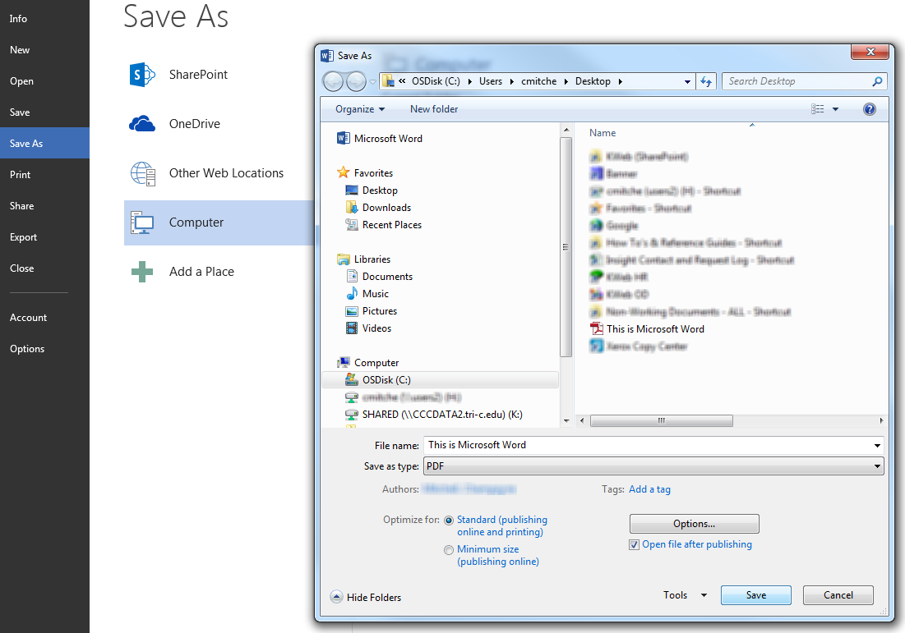

- The document will automatically open in PDF format when the conversion is complete. Repeat this process as needed.

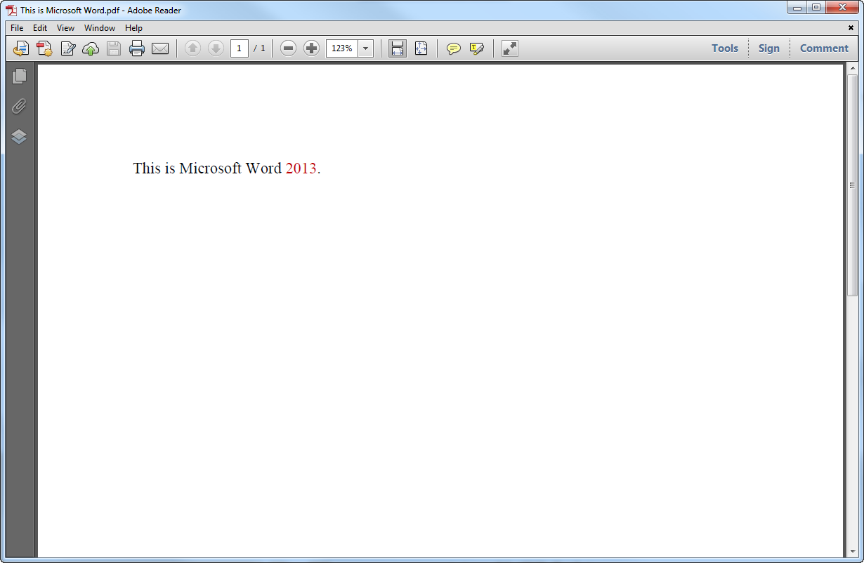

OPEN MICROSOFT WORD DOCUMENTS IN A DIFFERENT VIEW:

Microsoft Word 2013 has a variety of viewing options that can change how documents are displayed. Read Mode () hides most of the program toolbars and menus from view, and multiple pages are displayed side by side (). By default, documents downloaded from a website or attached to emails are automatically displayed in Read Mode.

Print Layout () is the most common view and displays how the document will look when it’s printed. Web Layout () displays how the document will look as a webpage. This layout is also great if there are wide tables in your document.

When you save a Microsoft Word file, it normally will retain the same display mode when the file is reopened. You can elect to change a document to Print Layout mode each time you open Word, OR you can change the Word’s program preferences to automatically open in the Print Layout mode. Each option is described in the sections to follow.

AUTOMATICALLY OPEN WORD DOCUMENTS IN PRINT LAYOUT MODE:

- Open a Word document, and then click the File tab.

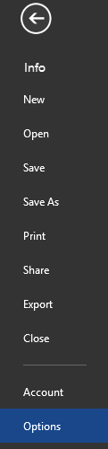
- Next, select Options from the Windows task pane.

- On the General tab, in the Start up options section, uncheck the box labeled: Open email attachments and other uneditable files in reading view.

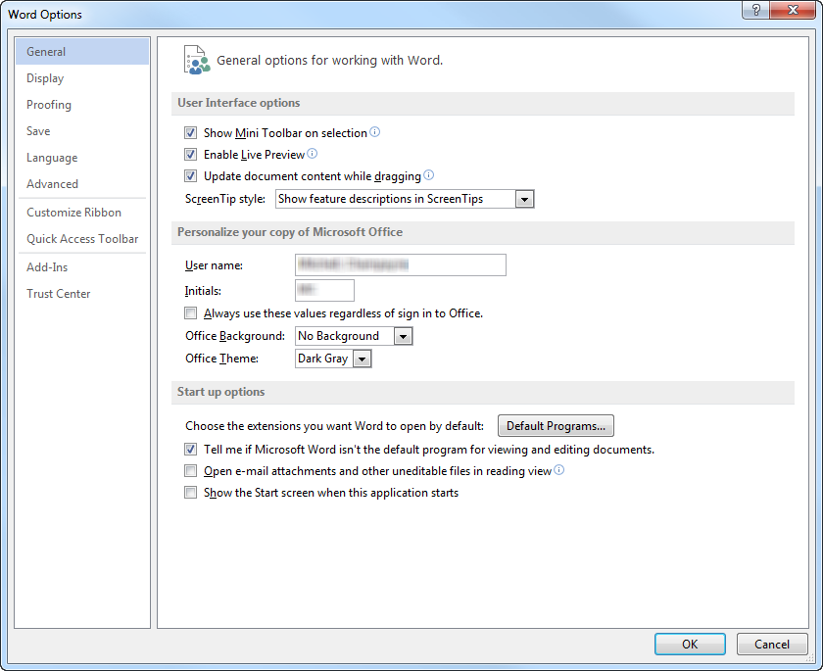

- Click the () button. This will open all Miscrosft Word documents in Print Layout mode each time the program is opened.

MANUALLY SWITCH DOCUMENTS TO PRINT LAYOUT MODE:

- Open the Word document. It will automatically open in Read-Only mode.

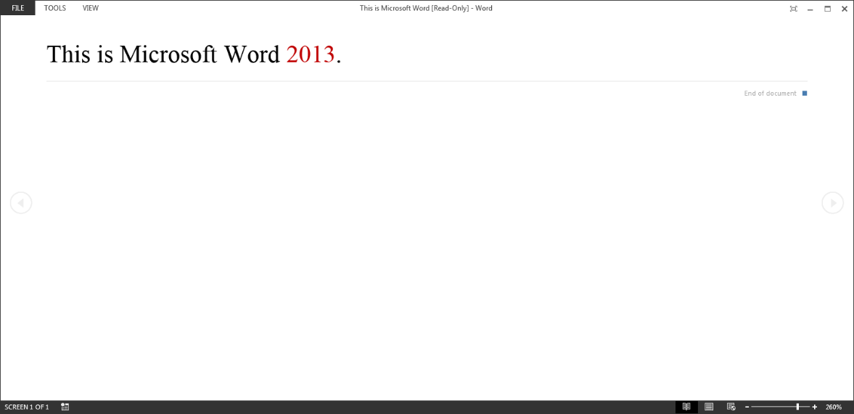

- Click View, then select Edit Document to switch to the Print Layout mode so you can make changes to the document and use the editing tools.

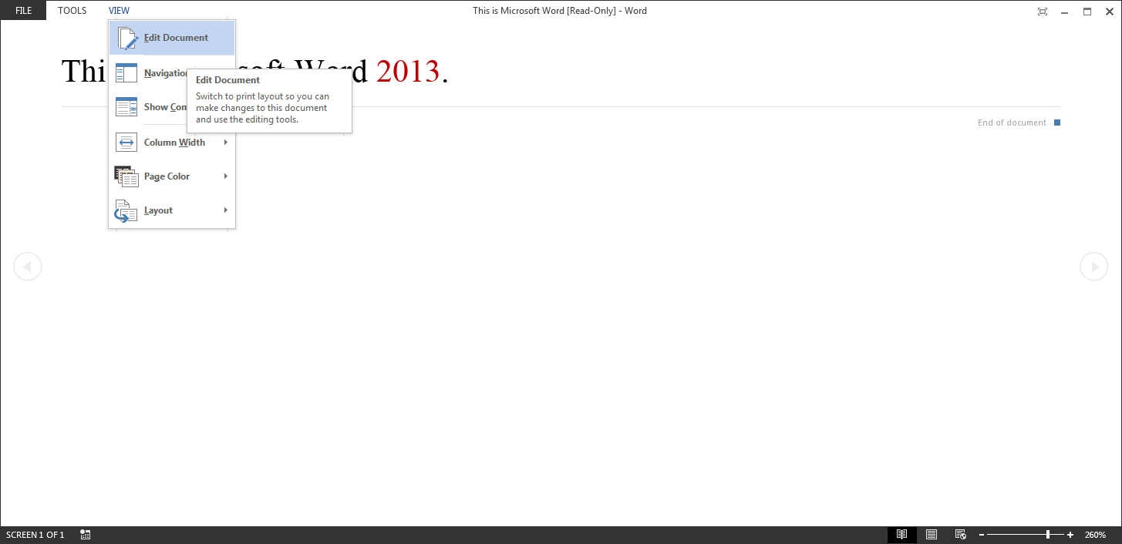
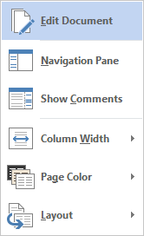
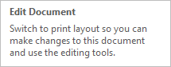

ACCESSING PUBLIC FOLDERS IN OUTLOOK:

- Click the () icon located on the Outlook task bar to display the public folders options.

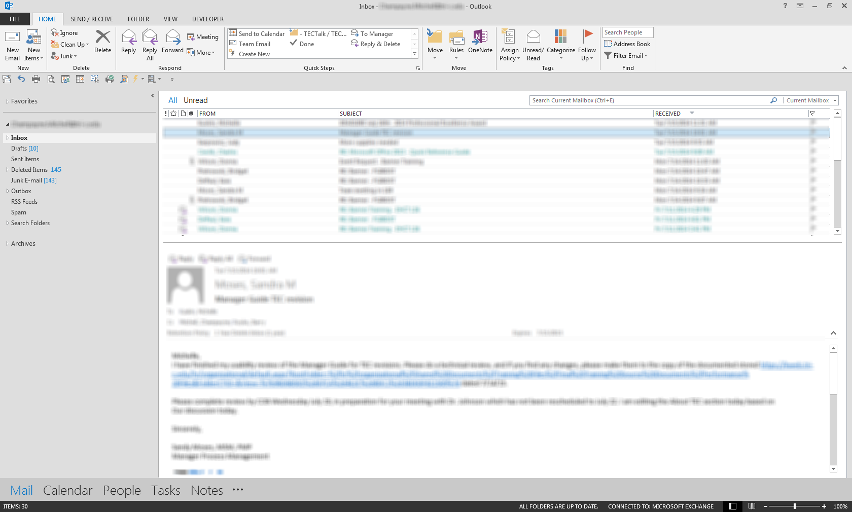

- The public folders menu will appear under ‘Navigation Options.’ Double-click on Folders.

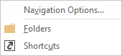

- Double-click on All Public Folders from the ‘Public Folders’ menu.
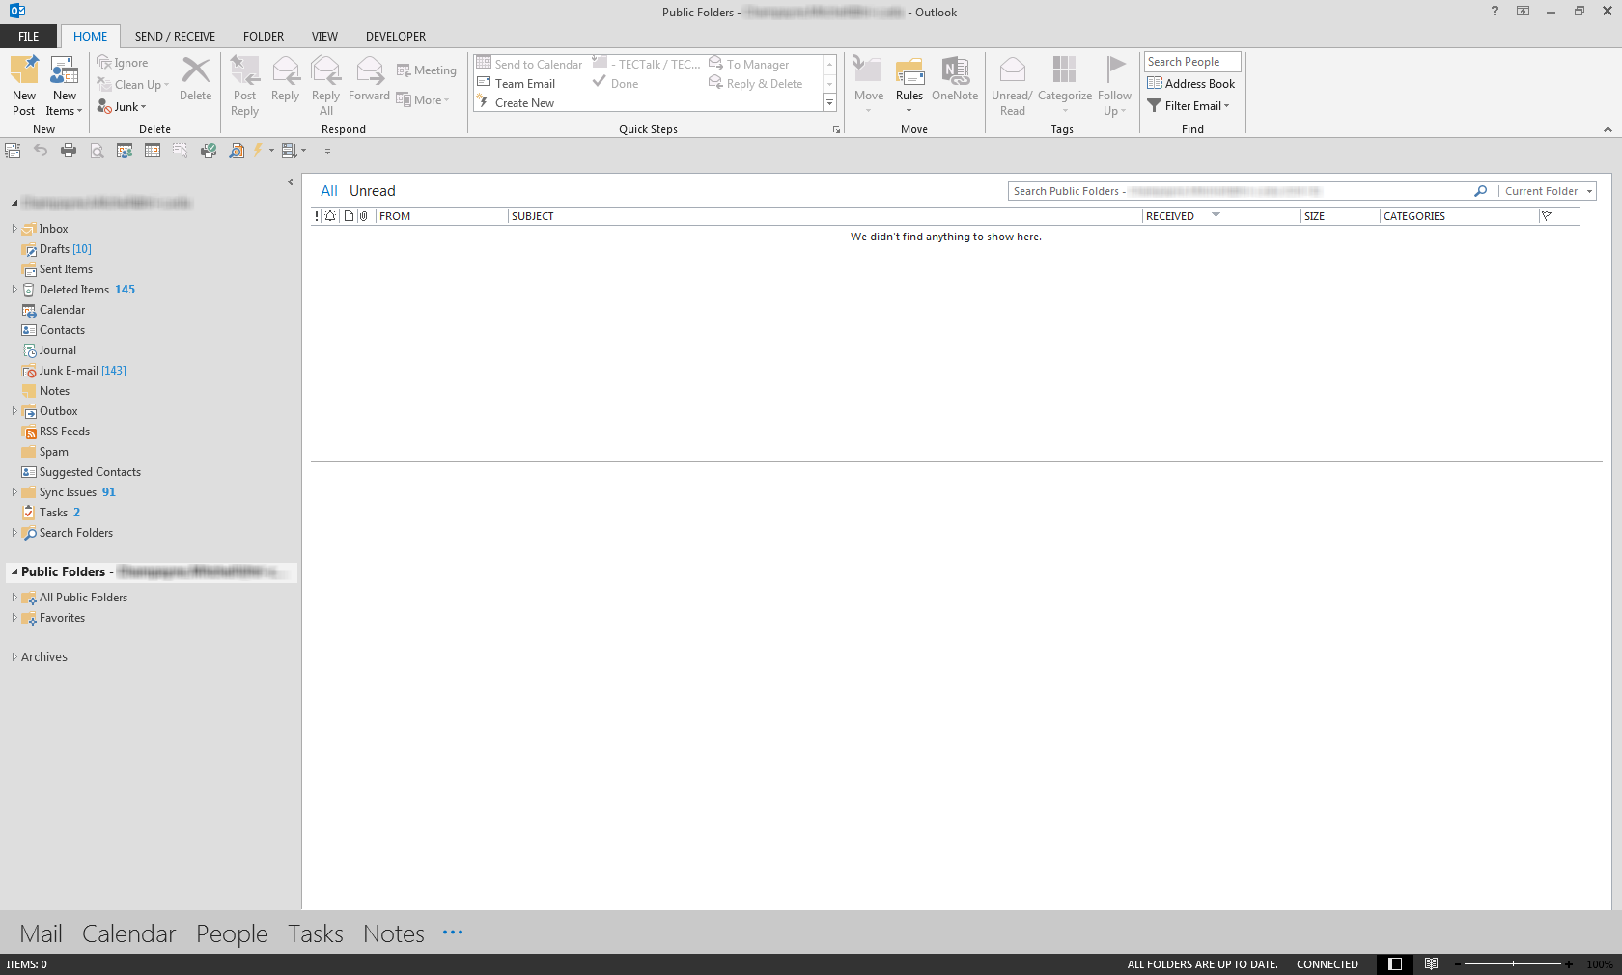

- All of Tri-C’s public folders will be displayed under All Public Folders. Click on the folder’s name to view the inbox for that folder. NOTE: You may have to do this every time you open Outlook and want to view the public folders.

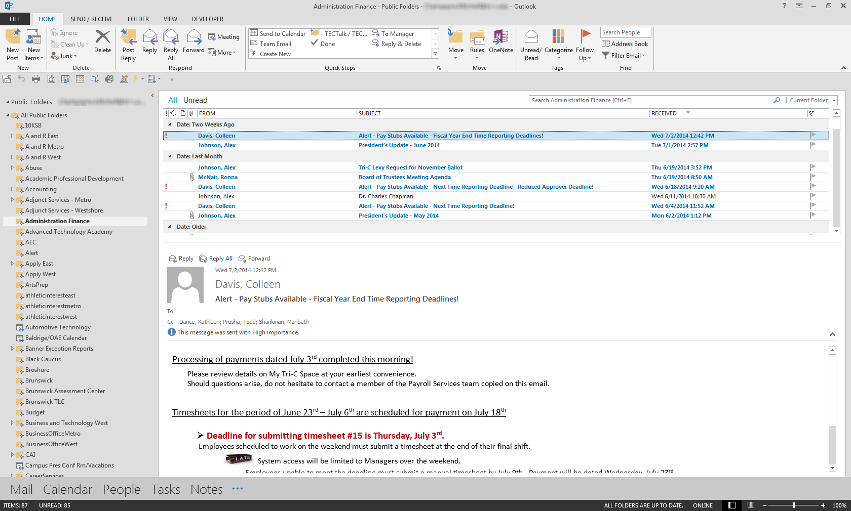
Click on the folder’s name to view the inbox for the folder.

OFFICE 2013 RESOURCES # 1:

Office programs have a built-in ‘Help’ function that contain resources such as links to articles and tutorials pertaining to the program. To access Microsoft Help:

- Open the Office 2013 program.

- Click the Help () icon in the upper right corner of the program, or hit the F1 key. The ‘Help’ box will open.

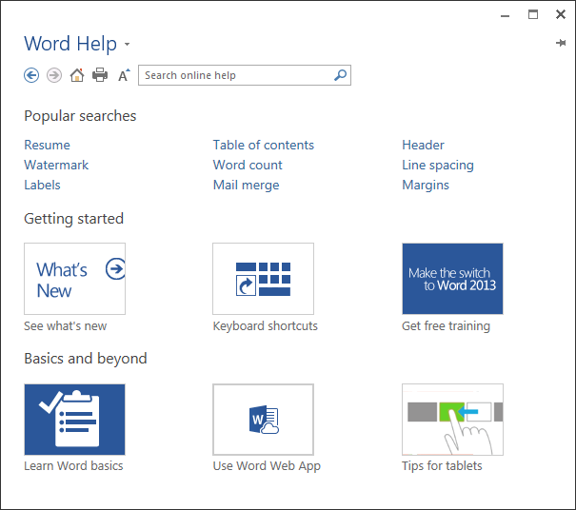
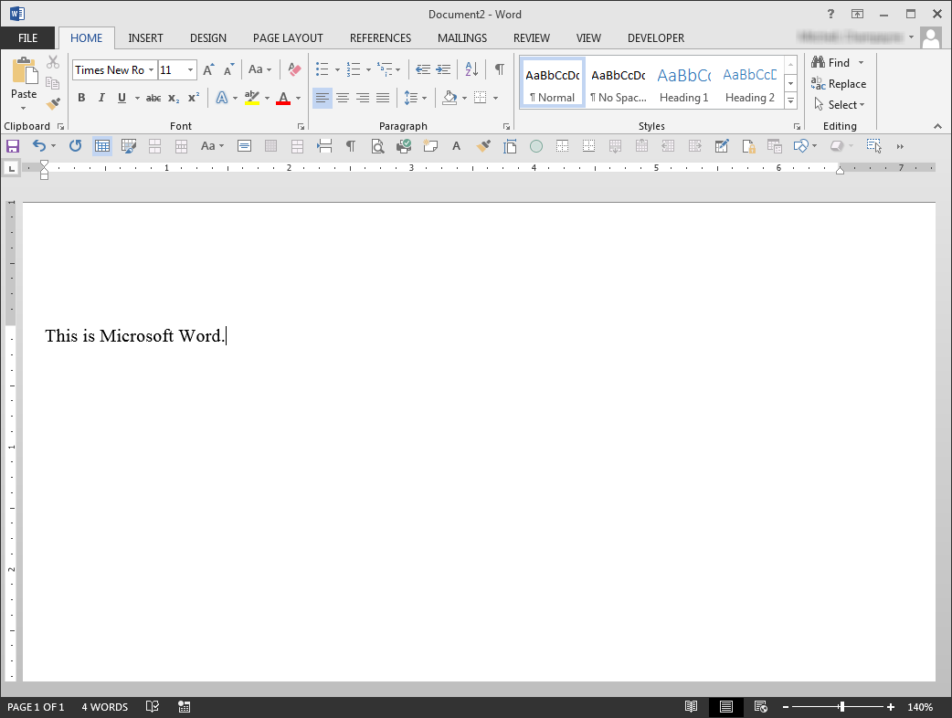

Search for help online by typing keywords in the ‘Search’ field. Click the icon to run your search
Read articles and access instructions on popular features of Office 2013 programs
Learn about all the new features of Office 2013, get keyboard shortcuts, and access free training tutorials on a variety of Office programs
Advanced users can learn more about Office 2013 programs and access additional resources including tips for tablet users

OFFICE 2013 RESOURCES # 2:

Microsoft provides many interactive resources such as online tutorials to help Office 2013 users become familiar with the new changes to Office 2013 Suite. Click on the icon next to the program below to learn about what’s new!

Click the icon to learn about the new features of the Office program!

Word | 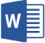
Excel | 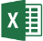
PowerPoint | 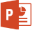
Outlook | 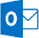
Access
OneNote
Publisher | 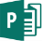

- Visit the Microsoft Office homepage to learn more about the new features of the Office 2013 suite. Or, copy/paste the link below into a web browser.

http://office.microsoft.com/en-us/support/getting-started-with-office-2013-FX102809998.aspx

- On the Microsoft Office homepage, click any link below the program to view the details within.

Read about all the new features of 2013 Office applications
View video tutorials on each Office 2013 application
Learn how to perform basic tasks within Office 2013 programs
Download a Quick Start Guide on each Office 2013 application. Follow the download instructions provided on the Microsoft webpage.

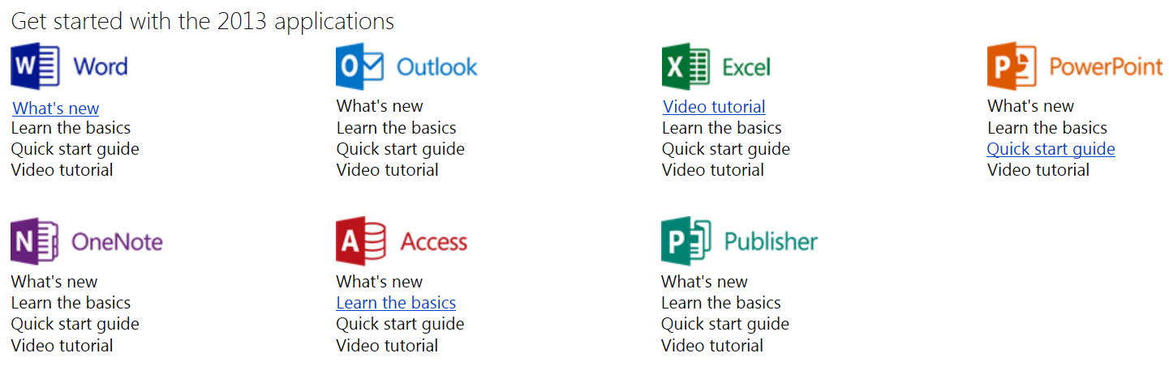

OFFICE 2013 RESOURCES # 3:

GCF LearnFree.org also provides a host of video tutorials and workbooks around the new Office 2013 software suite. Visit the site to learn more about new features of these Office 2013 programs.

Word 2013
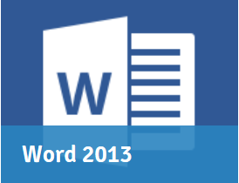 Word 2013 is the word processing application in Microsoft's new Office 2013. Learn how to use Word 2013's powerful tools for creating professional and eye-catching documents both for print and online sharing. Learn more about:
- Word Basics
- Working with Text
- Working with Objects
- Reviewing Documents and Collaboration
- Doing More with Word
- and Extras

PowerPoint 2013
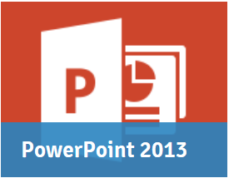 PowerPoint 2013 is a presentation program in the new Microsoft 2013 Office Suite. It allows you to create amazing slide presentations that can integrate images, video, narration, charts, and more. Learn more about:

- PowerPoint Basics
- Text & Objects
- More Objects
- Reviewing Presentations and Collaboration
- Customizing Your Presentation
- and Extras

Excel 2013
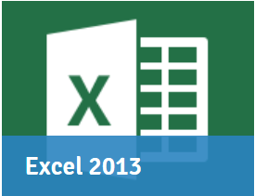 Excel 2013 is the spreadsheet application in Microsoft's new Office 2013. This tutorial will show you how to use the powerful tools in Excel 2013 for organizing, visualizing, and calculating your data. Learn more about:

- Excel Basics
- Formulas and Functions
- Working with Data
- Doing More with Excel
- and Extras

Access 2013
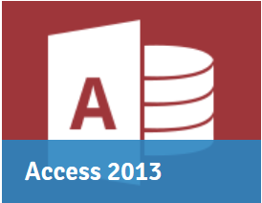 Access 2013 is a relational database application in the Microsoft 2013 Office Suite that allows users to enter, manage and run reports on large amounts of data. In this tutorial, you will learn the essential skills needed to use a database including entering data into forms and tables, running queries to search data, and producing meaningful reports. Learn more about:

- Access Basics
- Working with Data
- Running Queries and Reports
- Database Design Tips
- More Access Tasks
- and Extras

ADVANCED OFFICE 2013 RESOURCES:

Advanced users can learn more about Office 2013 programs and access additional resources through GCF LearnFree.org. Click on each box below to view more video tutorials about each program below.

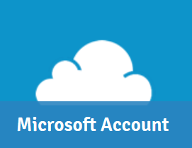
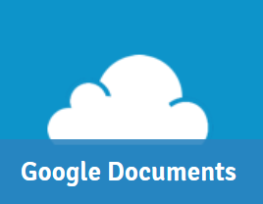
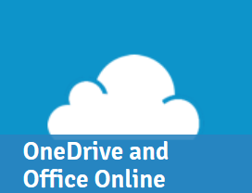
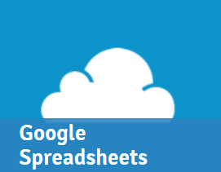
Microsoft Account (previously known as Windows Live) is a free cloud-based account that gives you access to Microsoft services, including Windows 8, OneDrive, and Skype.
Google Docs is a free cloud-based suite of tools for creating documents, spreadsheets, presentations, and more. This tutorial will cover the Documents application in Google Docs, in addition to showing you how to access and store your docs from Google Drive.
Office Online (previously known as Office Web Apps) is a free online version of Microsoft Office that includes Word, Excel, PowerPoint, and OneNote. OneDrive (previously known as SkyDrive), a cloud-based storage service that allows you to create, upload, and share Office documents and other files.
Google Docs is a free cloud-based suite of tools for creating documents, spreadsheets, presentations, and more. This tutorial will cover the Spreadsheets application in Google Docs, in addition to showing you how to access and store your Docs from Google Drive.

